Supporting Writing at Home

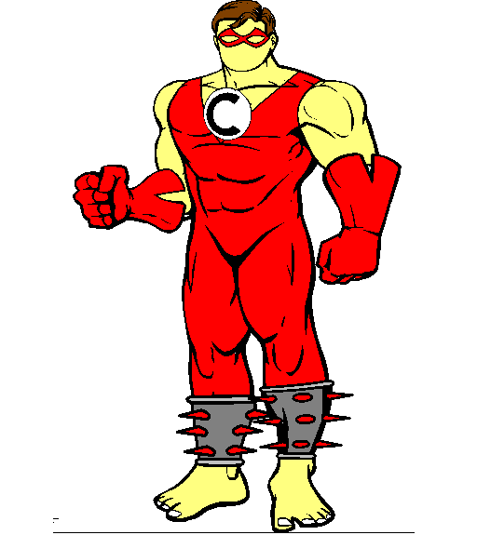

Thank you for helping me to support your child!
Mrs Black (HOD)
In CoAHS, we have introduced 4 VCOP superheroes to help the children with their writing:
Violet Vocab
V

- Violet has the power to help people really see how things look.
- She holds the secret of how characters and places really feel.
- Although words for sights and sounds are her favourite weapons she knows the importance of taste, touch and smell too.
- Violet knows how to pick just the right nouns or verbs to give writing real power over a reader.
- She uses adjectives and adverbs to hypnotise people into really seeing and feeling a piece of writing.

Noun - A word that names a person, place or thing: The tired, scared boy trudged slowly through the thick mud.

Adjective – A word used to describe a person, place or thing: The tired, scared boy trudged slowly through the thick mud.

Verb -A word to describe action; what is happening in the sentence: The tired, scared boy trudged slowly through the thick mud.

Adverb - A word to describe how the action is taking place: The tired, scared boy trudged slowly through the thick mud.

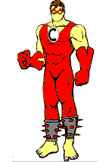
Captain Connective
C

- The Captain holds the team together and without him writing can be repetitive and boring, holding no power over the reader at all.
- His greatest power is to link ideas together providing a net to catch any reader.
- He gives the opportunity to add more detail to a sentence, but doesn’t always appear in the middle of sentences!

O
Incredible Opener

- The Incredible Opener is a master of disguise.
- Sometimes, he jumps up and tells the reader when something is happening. Suddenly, he is an adverb. Although, can be a link between ideas just like Captain Connective. Alternatively, he can express an opposite idea. On dark, windy nights, when even the wolves stay in their dens, he can be a whole phrase!
- He may seem like a bit of a Joker, but don’t be fooled, he helps add structure. It’s his job to hook the reader in and keep him reading.

Doctor
Punctuation
P

- The Doctor’s basic weapon is the power to stop and start a sentence. If capital letters and full stops are missing, or in the wrong place, writing is weak. It will not have the power to grab a reader!
- His control over the reader is reinforced by the use of commas to separate ideas. They work well when combined with connectives and openers.
- He reveals what characters actually say with speech marks.
- Does he ask questions? Of course, that’s a great weapon for hooking a reader.

Can you improve your writing to help the incredible VCOP super heroes save the world from a fate worse than dullness?
Encourage your child to improve the sentences that they write, using VCOP. For example,
The cat went along the wall.

We can improve this sentence using:
Violet Vocabulary: The fluffy ginger cat prowled along the red brick wall.
Captain Connective: The fluffy ginger cat prowled along the red brick wall because he was spying on a juicy bird.
Incredible Opener: Whilst licking his lips, the fluffy ginger cat prowled along the red brick wall because he was spying on a juicy bird.
Dr Punctuation: Whilst licking his lips, the fluffy ginger cat (who had sharp teeth) prowled along the red brick wall because he was spying on a bird!
Helping your child with V.C.O.P at home.

V-Violet Vocabulary (Wow words!)
• Talk about and write down interesting (Wow) words in the stories you are reading at home.
• Try using the words you have found in a sentence.
• Have a mini-quiz: ‘How many words can you think of instead of ‘said’?’ or ‘went’, ‘nice’, ‘good’. Put each one in a sentence.
• Give your child a Wow word to put into a sentence. How many different sentences can they make?
• Give your child two different words and ask them to make different sentences from them. E.g.: ‘magical’ and ‘boy’.
• Remind them that they should use the other heroes when writing these sentences!

C-Captain Connective
Connectives are used to join sentences together. The simplest connective to use is ‘and’, as in: Bill went to the shops and he bought an ice-cream.
• Try to search for connectives in the stories you read at home. Use them in a different sentence.
• Try rearranging sentences with the connectives at the start. E.g. The little boy shivered despite it being warm in the cave. – Despite it being warm in the cave the little boy shivered.
• Give your child a connective and ask them to use it in a sentence.

O- The Incredible Opener
An opener is the first word used in a sentence. When children start on their writing journey most sentences initially begin with ‘I’. To develop this try:
• Searching for openers in the stories you read at home and use them to start your own sentences.
• Give your child an opener and ask them to complete the sentence.

P- Dr. Punctuation
• Look at different types of punctuation in your reading at home.
• Ask your child to give examples of when they would use a ? or ! or . or , - use the punctuation pyramid.
• Use different types of punctuation in different sentences.
Different ways to start a sentence –
The Incredible Opener!

Ways to Start Example
“When” starter Last night….
“How” starter Carefully, he crept …..
“Where” starter Across the road….
Name starter Bill wandered ….
Simile Like an eel …..
Adjective starter Tall trees towered overhead
“-ed” clause Excited, Joanna ran …..
“-ing” clause Running quickly, Tim felt …..

Time Connectives

Before After Later After a while

Soon Then Afterwards At dawn

Once Suddenly Eventually Until

Before Finally Following Firstly

When Lastly In the end Soon

Later After tea Next Now

Meanwhile While Tomorrow One day

Previously Since At that moment

At the beginning

Alternatives to went

moving slowly
shuffled toddled crept

meandered plodded trudged wandered

moving unsteadily.
lumbered shuffled toddled doddered

waddled plodded limped wobbled

lurched

Moving loudly or quickly
stomped marched strolled traipsed

strutted hiked roamed paced

stepped pounded

Moving quietly
meandered prowled sneaked tiptoed

crept pattered

